PH126 Logic I Lecture 9
Lecturer: s.butterfill@warwick.ac.uk

Truth table for →
Assuming that the rules of Fitch are such that it is impossible to prove an argument which is not logically valid, the truth-table for → is fixed if we accept →Elim and →Intro.
How do the rules of proof for → fix its truth table?
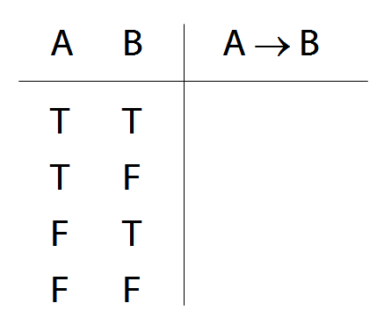

‘If’ and ‘→’ do not match
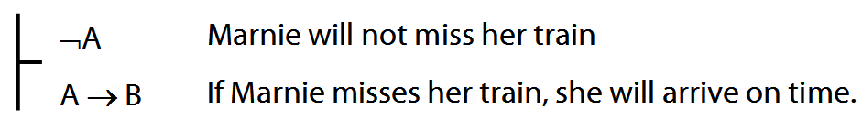

‘If’ and ‘→’ do match
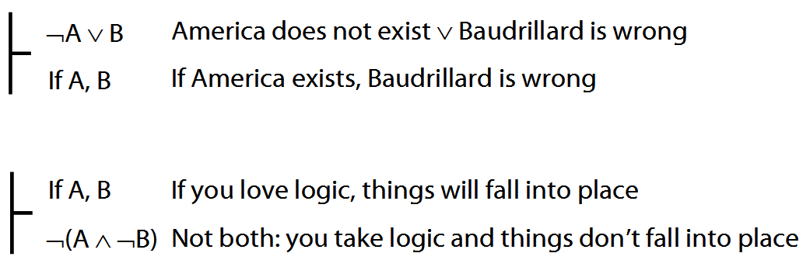
Multiple quantifiers: simple examples
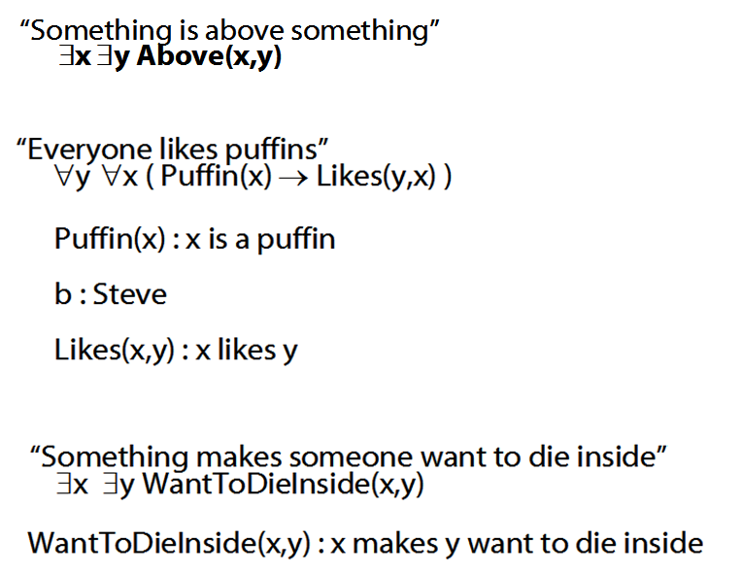

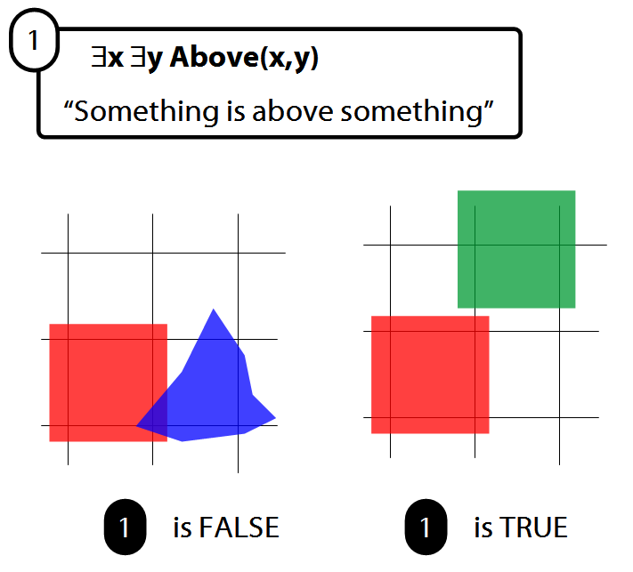

The Soundness & Completeness Theorems
‘A├ B’ means there is a proof of B using premises A
‘├ B’ means there is a proof of B using no premises
‘A╞ B’ means B is a logical consequence of A
‘╞ B’ means B is a tautology
‘A╞_{T} B’ means B is a logical consequence of A just in virtue of the meanings of truth-functions (the textbook LPL calls this ‘tautological consequence’)
Soundness: If A├ B then A╞ B
I.e. if you can prove it in Fitch, it’s valid

Completeness: If A╞_{T} B then A ├ B
I.e. if it’s valid just in virtue of the meanings of truth functions, you can prove it in Fitch

Proof Example using negation-Intro
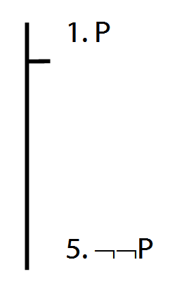

Substitution of logical equivalents
Two sentences are logically equivalent when each is a logical consequence of the other.
If * and # are logically equivalent, then you take a complex formula and replace * with # without changing the truth table of the complex formula.
Example. Because ¬( R ∨ ¬P ) is logically equivalent to ¬R ∧ P, it follows that:
P ∨ ¬( Q ∧ ¬( R ∨ ¬P ) ) is logically equivalent to P ∨ ¬( Q ∧ (¬R ∧ P) )
And because ¬( Q ∧ (¬R ∧ P) ) is logically equivalent to ¬Q ∨ (R ∨ ¬ P), it follows that P ∨ ¬( Q ∧ (¬R ∧ P) ) is logically equivalent to P ∨ ( ¬Q ∨ (R ∨ ¬ P) ).
Example proof
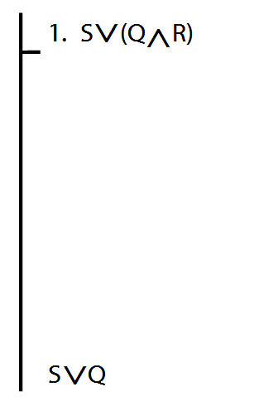
Fubar rules
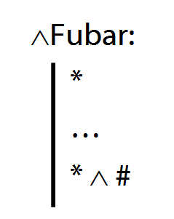
Q1. What would be wrong with adding ∧Fubar to Fitch?
Q2. What would be wrong with having ∧Fubar in any system of proof?

Tonk
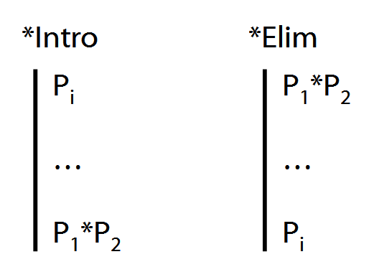

Exercises 05
For your sixth seminar
Not for fast groups
A. From the LPL textbook:
7.9 (truth functions)
6.17–20 (proof)
6.33, 6.40
DO NOT USE TAUT CON. EVER.
8.24–25 (proofs/counterexamples)
12.4–5, *12.6–7 (counterexamples)

B. For each of the following sentences of FOL, give a logically equivalent sentence of idiomatic English using the specified interpretation. Your English sentences should be as concise as possible.
Domain : people and actions
D(x) : x is desirable
V(x) : x is virtuous
A(x) : x is an action
H(x) : x is a person
P(x,y) : x performed y
i. ∀x [ D(x) → V(x) ]
ii. ∀x [ [A(x)∧ D(x) ] → V(x) ] ]
iii. ∃x [ A(x) ∧ ¬[ D(x) → V(x) ] ]
*iv. ∃x ∀y [[[H(x) ∧ A(y)] ∧ P(x,y)] → V(y)]
**v. ¬∃x [∃y [H(x) ∧ P(x,y) ∧ A(y) ∧ ¬V(y)]
∧ ¬∃z[P(x,z) ∧ A(z) ∧ V(z)]]

